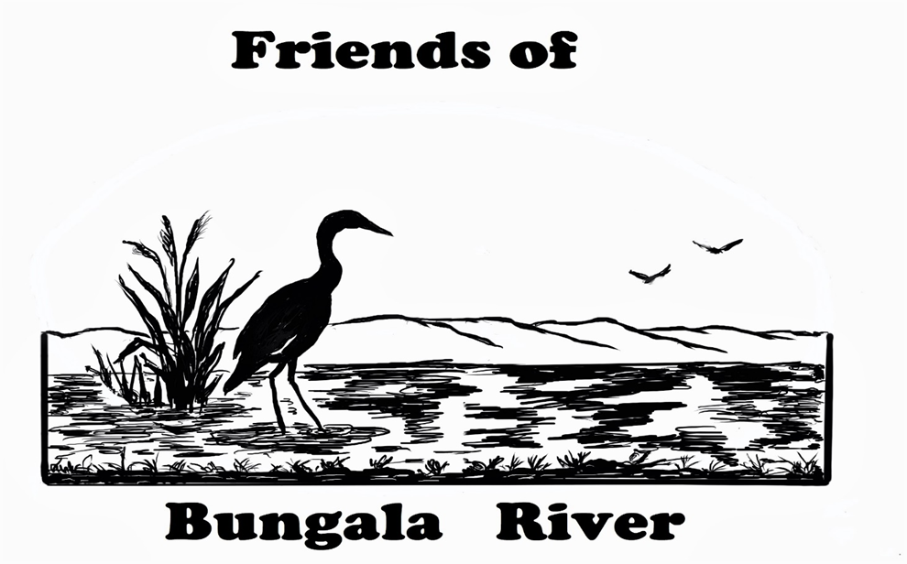

Friends of Bungala River – Newsletter May 2025

Welcome to the first edition of the Friends of Bungala River (FoBR) newsletter! We’re excited to launch this twice-yearly update to keep our wonderful supporters and volunteers informed about our work, plans, and achievements in restoring the Bungala River and its surrounding environment.

🏞 Who We Are
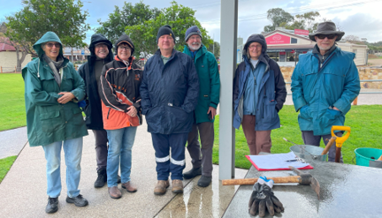
A quick recap for those not that familiar with what we do. The Friends of Bungala River group began in September 2022, formed by passionate members of the Normanville community concerned about the health of the Bungala River and Salt Creek. With support from:
- The Fleurieu Environment Centre
- The Fleurieu Coastal Community Nursery
- The Yankalilla District Residents Association
- The Hills and Fleurieu Landscape Board
- The Yankalilla Council
FoBR has grown into a committed team of volunteers working to rehabilitate this vital ecosystem. We meet every month, rain or shine and work in different areas of the Bungala Park in Normanville. To find out more you can join us on our Facebook Group or go into the Fleurieu Environment Centre shop in Normanville Main Street.

What We've Achieved
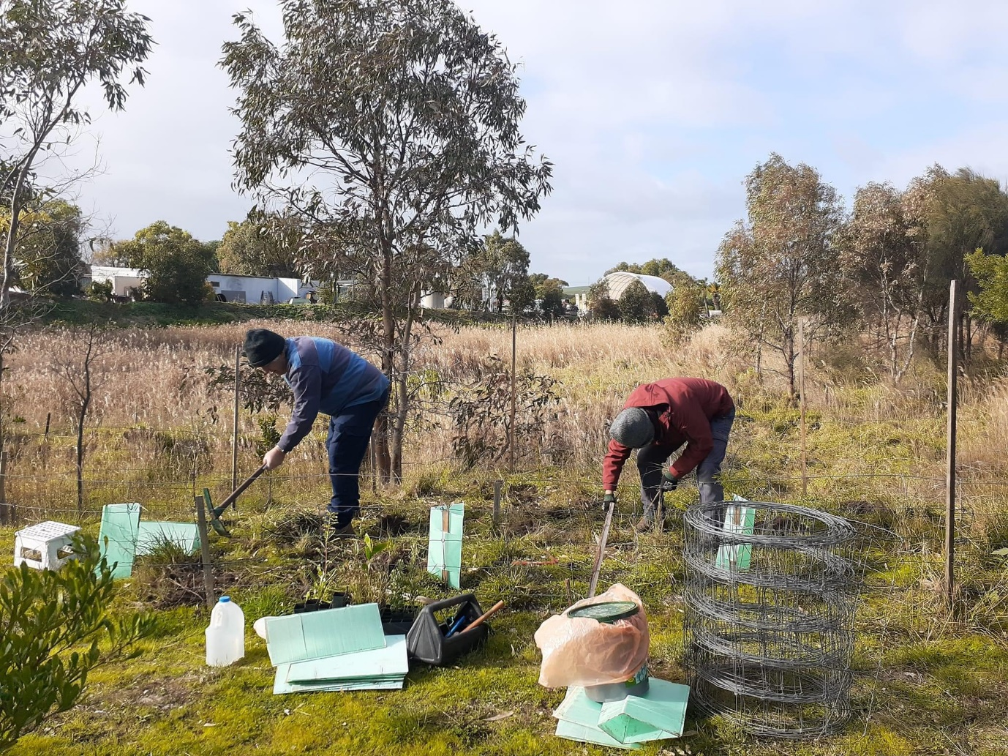
- Over 2,000 native plants have been planted, including 500 during our Community Tree Planting Day in July 2023.
- Restoration now stretches from Hay Flat Road Bridge through to the Salt Creek intersection, including areas adjacent to the caravan park.
- Weed management, especially the removal of feral olives, continues to be a major focus.

What We're Working On
Despite drought conditions this year, we've continued:
- Watering last year’s plantings to support their survival.
- Installing larger wire guards to protect growing trees from kangaroo damage.
- Preparing new planting areas with a focus on native grasses, aiming to build a sustainable seed bank for future projects.
Weed Management
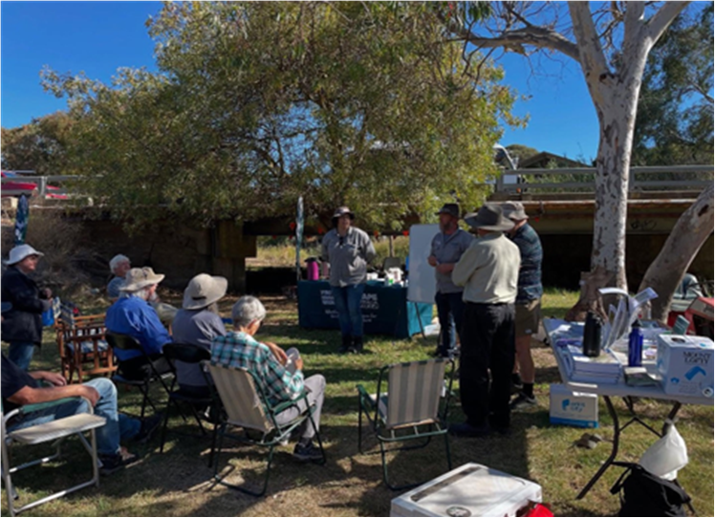

We recently took part in an Olive Eradication Workshop hosted by our local Fleurieu & Hills Landscape Stewardship Officers, Chelsea Balestrin and Jeff Edwards. This was an excellent training program with plenty of hands-on practice. This will help improve our techniques for managing feral olive trees into the future.
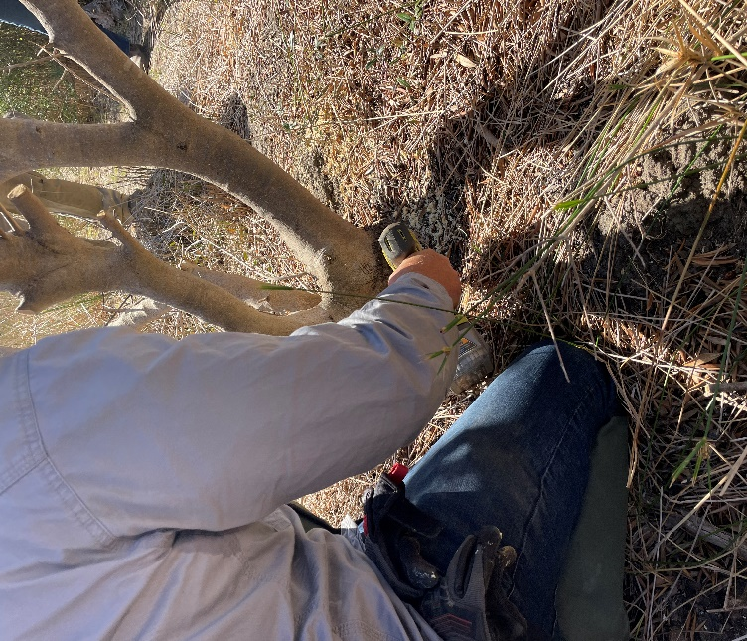

Looking Ahead

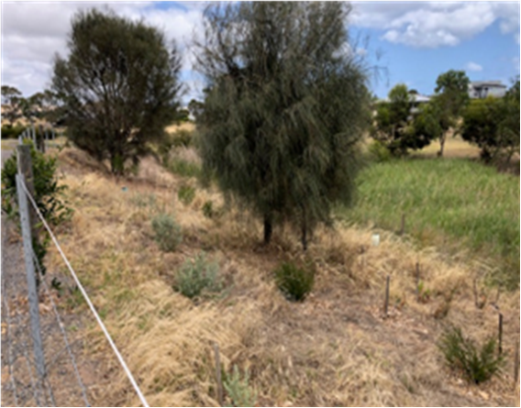
- New Plantings: We are expanding our native grass zones and preserving patches of remnant native vegetation.
- Educational Trails: Plans are underway to install plant signs along key walking paths, helping locals and visitors learn more about our unique flora.
- Strategic Planning: Thanks to a Yankalilla Council Community Grant, we now have a 5-Year Action Plan developed by ecologist Phil Barron to guide our future activities.

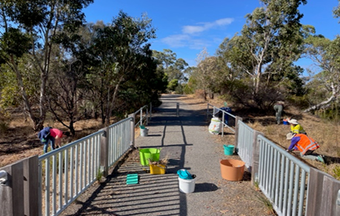 | 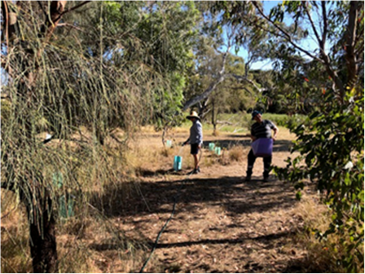

Newsletter May 2025

🙌 Get Involved
Monthly Working Bees
🗓 3rd Friday of every month
📍 Meet at the BBQ area, Bungala Park, Normanville
🕘 All welcome – bring a hat, gloves, and your enthusiasm!
Contact Us:
📧 Email: fobr@flec.com.au
📘 Facebook: Friends of Bungala River
More Details at The Fleurieu Environment Centre

Thank you for your continued support in restoring and protecting the Bungala River. Together, we're creating a healthier environment and a more beautiful place for our community to enjoy.

